Print Out Source Code Program

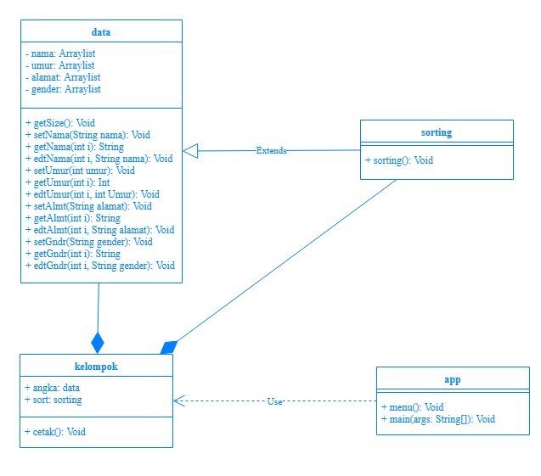

Print Out Source Code Program

import java.util.ArrayList;

public class data {

private ArrayList nama = new ArrayList();

private ArrayList umur = new ArrayList();

private ArrayList alamat = new ArrayList();

private ArrayList gender = new ArrayList();

int getSize(){

return umur.size();

}

void setNama(String nama){

this.nama.add(nama);

}

String getNama(int i){

return (String) nama.get(i);

}

void edtNama(int i, String nama){

this.nama.set(i, nama);

}

Keterangan Source Code :

------------------------------------------------------------------------------------------------------------------------------------------------------------------------------------------------------------------------------------------------------------------------------------------------------------------------------------------------------------------------------------------------------------------------------------------------------------------------------------------------------------------------------------------------------------------------------------------------------------------------------------------------------------------------------------------------------------------------------------------------------------------------------------------------------------------------------------------------------------------------------------------------------------------------------------------------------------------------------------------------------------------------------------------------------------------------------------------------------------------------------------------------------------------------------------------------------------------------------------------------------------------------------------------------------------------------------------------------------------------------------------------------------------------------------------------------------------------------------------------------------------------------------------------------------------------------------------------------------------------------------------------------

Print Out Source Code Program

void setUmur(int umur){

this.umur.add(umur);

}

int getUmur(int i){

return (int) umur.get(i);

}

void edtUmur(int i, int Umur){

this.umur.set(i, Umur);

}

void setAlmt(String alamat){

this.alamat.add(alamat);

}

String getAlmt(int i){

return (String) alamat.get(i);

}

void edtAlmt(int i, String alamat){

this.alamat.set(i, alamat);

}

Keterangan Source Code :

------------------------------------------------------------------------------------------------------------------------------------------------------------------------------------------------------------------------------------------------------------------------------------------------------------------------------------------------------------------------------------------------------------------------------------------------------------------------------------------------------------------------------------------------------------------------------------------------------------------------------------------------------------------------------------------------------------------------------------------------------------------------------------------------------------------------------------------------------------------------------------------------------------------------------------------------------------------------------------------------------------------------------------------------------------------------------------------------------------------------------------------------------------------------------------------------------------------------------------------------------------------------------------------------------------------------------------------------------------------------------------------------------------------------------------------------------------------------------------------------------------------------------------------------------------------------------------------------------------------------------------------------

Print Out Source Code Program

void setGndr(String gender){

this.gender.add(gender);

}

String getGndr(int i){

return (String) gender.get(i);

}

void edtGndr(int i, String gender){

this.gender.set(i, gender);

}

}

Keterangan Source Code :

------------------------------------------------------------------------------------------------------------------------------------------------------------------------------------------------------------------------------------------------------------------------------------------------------------------------------------------------------------------------------------------------------------------------------------------------------------------------------------------------------------------------------------------------------------------------------------------------------------------------------------------------------------------------------------------------------------------------------------------------------------------------------------------------------------------------------------------------------------------------------------------------------------------------------------------------------------------------------------------------------------------------------------------------------------------------------------------------------------------------------------------------------------------------------------------------------------------------------------------------------------------------------------------------------------------------------------------------------------------------------------------------------------------------------------------------------------------------------------------------------------------------------------------------------------------------------------------------------------------------------------------------

Print Out Source Code Program

public class sorting extends data{

void sorting() {

int tempUmr, kecil;

String tempNama, tempAlmt, tempGndr;

for(int i = 0; i < getSize() ; i++){

kecil = i;

for(int j = i+1; j < getSize(); j++){

if (getUmur(j) < getUmur(kecil))

kecil = j; }

tempNama = getNama(i);

edtNama(i, getNama(kecil));

edtNama(kecil, tempNama);

tempUmr = getUmur(i);

edtUmur(i,getUmur(kecil));

edtUmur(kecil, tempUmr);

tempAlmt = getAlmt(i);

edtAlmt(i,getAlmt(kecil));

edtAlmt(kecil, tempAlmt);

Keterangan Source Code :

------------------------------------------------------------------------------------------------------------------------------------------------------------------------------------------------------------------------------------------------------------------------------------------------------------------------------------------------------------------------------------------------------------------------------------------------------------------------------------------------------------------------------------------------------------------------------------------------------------------------------------------------------------------------------------------------------------------------------------------------------------------------------------------------------------------------------------------------------------------------------------------------------------------------------------------------------------------------------------------------------------------------------------------------------------------------------------------------------------------------------------------------------------------------------------------------------------------------------------------------------------------------------------------------------------------------------------------------------------------------------------------------------------------------------------------------------------------------------------------------------------------------------------------------------------------------------------------------------------------------------------------------

Print Out Source Code Program

tempGndr = getGndr(i);

edtGndr(i,getGndr(kecil));

edtGndr(kecil, tempGndr);

}

}

}

Keterangan Source Code :

------------------------------------------------------------------------------------------------------------------------------------------------------------------------------------------------------------------------------------------------------------------------------------------------------------------------------------------------------------------------------------------------------------------------------------------------------------------------------------------------------------------------------------------------------------------------------------------------------------------------------------------------------------------------------------------------------------------------------------------------------------------------------------------------------------------------------------------------------------------------------------------------------------------------------------------------------------------------------------------------------------------------------------------------------------------------------------------------------------------------------------------------------------------------------------------------------------------------------------------------------------------------------------------------------------------------------------------------------------------------------------------------------------------------------------------------------------------------------------------------------------------------------------------------------------------------------------------------------------------------------------------------

Print Out Source Code Program

import java.util.ArrayList;

public class kelompok {

data data = new data();

sorting sort = new sorting();

void cetak(){

sort.sorting();

System.out.println("\nBalita: ");

for(int i = 0; i < sort.getSize(); i++){

if(sort.getUmur(i) < 5){

System.out.println("\nNama: " + sort.getNama(i));

System.out.println("Umur: " + sort.getUmur(i));

System.out.println("Alamat: " + sort.getAlmt(i));

System.out.println("Jenis Kelamin: " + sort.getGndr(i) + "\n");

}}

Keterangan Source Code :

------------------------------------------------------------------------------------------------------------------------------------------------------------------------------------------------------------------------------------------------------------------------------------------------------------------------------------------------------------------------------------------------------------------------------------------------------------------------------------------------------------------------------------------------------------------------------------------------------------------------------------------------------------------------------------------------------------------------------------------------------------------------------------------------------------------------------------------------------------------------------------------------------------------------------------------------------------------------------------------------------------------------------------------------------------------------------------------------------------------------------------------------------------------------------------------------------------------------------------------------------------------------------------------------------------------------------------------------------------------------------------------------------------------------------------------------------------------------------------------------------------------------------------------------------------------------------------------------------------------------------------------------

Print Out Source Code Program

System.out.println("\nAnak - Anak: ");

for(int i = 0; i < sort.getSize(); i++){

if(sort.getUmur(i) >= 5 && sort.getUmur(i) < 17){

System.out.println("\nNama: " + sort.getNama(i));

System.out.println("Umur: " + sort.getUmur(i));

System.out.println("Alamat: " + sort.getAlmt(i));

System.out.println("Jenis Kelamin: " + sort.getGndr(i) + "\n");

}

}

Keterangan Source Code :

------------------------------------------------------------------------------------------------------------------------------------------------------------------------------------------------------------------------------------------------------------------------------------------------------------------------------------------------------------------------------------------------------------------------------------------------------------------------------------------------------------------------------------------------------------------------------------------------------------------------------------------------------------------------------------------------------------------------------------------------------------------------------------------------------------------------------------------------------------------------------------------------------------------------------------------------------------------------------------------------------------------------------------------------------------------------------------------------------------------------------------------------------------------------------------------------------------------------------------------------------------------------------------------------------------------------------------------------------------------------------------------------------------------------------------------------------------------------------------------------------------------------------------------------------------------------------------------------------------------------------------------------

Print Out Source Code Program

System.out.println("\nDewasa: ");

for(int i = 0; i < sort.getSize(); i++){

if(sort.getUmur(i) >= 17 && sort.getUmur(i) < 50){

System.out.println("\nNama: " + sort.getNama(i));

System.out.println("Umur: " + sort.getUmur(i));

System.out.println("Alamat: " + sort.getAlmt(i));

System.out.println("Jenis Kelamin: " + sort.getGndr(i) + "\n");

}

}

Keterangan Source Code :

------------------------------------------------------------------------------------------------------------------------------------------------------------------------------------------------------------------------------------------------------------------------------------------------------------------------------------------------------------------------------------------------------------------------------------------------------------------------------------------------------------------------------------------------------------------------------------------------------------------------------------------------------------------------------------------------------------------------------------------------------------------------------------------------------------------------------------------------------------------------------------------------------------------------------------------------------------------------------------------------------------------------------------------------------------------------------------------------------------------------------------------------------------------------------------------------------------------------------------------------------------------------------------------------------------------------------------------------------------------------------------------------------------------------------------------------------------------------------------------------------------------------------------------------------------------------------------------------------------------------------------------------

Print Out Source Code Program

System.out.println("\nTua: ");

for(int i = 0; i < sort.getSize(); i++){

if(sort.getUmur(i) >= 50){

System.out.println("\nNama: " + sort.getNama(i));

System.out.println("Umur: " + sort.getUmur(i));

System.out.println("Alamat: " + sort.getAlmt(i));

System.out.println("Jenis Kelamin: " + sort.getGndr(i) + "\n");

}

}

}

}

Keterangan Source Code :

------------------------------------------------------------------------------------------------------------------------------------------------------------------------------------------------------------------------------------------------------------------------------------------------------------------------------------------------------------------------------------------------------------------------------------------------------------------------------------------------------------------------------------------------------------------------------------------------------------------------------------------------------------------------------------------------------------------------------------------------------------------------------------------------------------------------------------------------------------------------------------------------------------------------------------------------------------------------------------------------------------------------------------------------------------------------------------------------------------------------------------------------------------------------------------------------------------------------------------------------------------------------------------------------------------------------------------------------------------------------------------------------------------------------------------------------------------------------------------------------------------------------------------------------------------------------------------------------------------------------------------------------

Print Out Source Code Program

import java.util.Scanner;

public class app{

static void menu(){

System.out.print("Menu\n1.Input Data\n2.Cetak\nPilih ");

}

public static void main(String[] args) {

kelompok data = new kelompok();

Scanner input = new Scanner(System.in);

String nama, alamat, gender;

int umur, pilih = 0;

do {

menu();

pilih = input.nextInt();

Keterangan Source Code :

------------------------------------------------------------------------------------------------------------------------------------------------------------------------------------------------------------------------------------------------------------------------------------------------------------------------------------------------------------------------------------------------------------------------------------------------------------------------------------------------------------------------------------------------------------------------------------------------------------------------------------------------------------------------------------------------------------------------------------------------------------------------------------------------------------------------------------------------------------------------------------------------------------------------------------------------------------------------------------------------------------------------------------------------------------------------------------------------------------------------------------------------------------------------------------------------------------------------------------------------------------------------------------------------------------------------------------------------------------------------------------------------------------------------------------------------------------------------------------------------------------------------------------------------------------------------------------------------------------------------------------------------

Print Out Source Code Program

switch(pilih){

case 1:

System.out.println("");

input.nextLine();

System.out.print("Masukkan Nama: ");nama = input.nextLine();

System.out.print("Masukkan Umur: ");umur = input.nextInt();

input.nextLine();

System.out.print("Masukkan Alamat: ");alamat = input.nextLine();

System.out.print("Masukkan Jenis Kelamin(L/P): ");gender = input.nextLine();

data.sort.setNama(nama);

data.sort.setUmur(umur);

data.sort.setAlmt(alamat);

data.sort.setGndr(gender);

System.out.println("");

break;

Keterangan Source Code :

------------------------------------------------------------------------------------------------------------------------------------------------------------------------------------------------------------------------------------------------------------------------------------------------------------------------------------------------------------------------------------------------------------------------------------------------------------------------------------------------------------------------------------------------------------------------------------------------------------------------------------------------------------------------------------------------------------------------------------------------------------------------------------------------------------------------------------------------------------------------------------------------------------------------------------------------------------------------------------------------------------------------------------------------------------------------------------------------------------------------------------------------------------------------------------------------------------------------------------------------------------------------------------------------------------------------------------------------------------------------------------------------------------------------------------------------------------------------------------------------------------------------------------------------------------------------------------------------------------------------------------------------

Print Out Source Code Program

case 2:

data.cetak();

break;

}

} while (pilih != 3);

}

}

Keterangan Source Code :

------------------------------------------------------------------------------------------------------------------------------------------------------------------------------------------------------------------------------------------------------------------------------------------------------------------------------------------------------------------------------------------------------------------------------------------------------------------------------------------------------------------------------------------------------------------------------------------------------------------------------------------------------------------------------------------------------------------------------------------------------------------------------------------------------------------------------------------------------------------------------------------------------------------------------------------------------------------------------------------------------------------------------------------------------------------------------------------------------------------------------------------------------------------------------------------------------------------------------------------------------------------------------------------------------------------------------------------------------------------------------------------------------------------------------------------------------------------------------------------------------------------------------------------------------------------------------------------------------------------------------------------------

Print Out Source Code Program

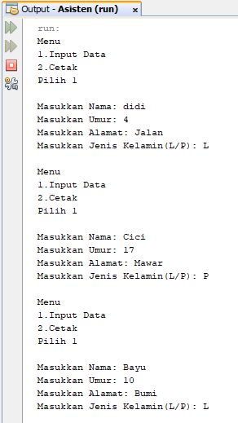

Keterangan Source Code :

------------------------------------------------------------------------------------------------------------------------------------------------------------------------------------------------------------------------------------------------------------------------------------------------------------------------------------------------------------------------------------------------------------------------------------------------------------------------------------------------------------------------------------------------------------------------------------------------------------------------------------------------------------------------------------------------------------------------------------------------------------------------------------------------------------------------------------------------------------------------------------------------------------------------------------------------------------------------------------------------------------------------------------------------------------------------------------------------------------------------------------------------------------------------------------------------------------------------------------------------------------------------------------------------------------------------------------------------------------------------------------------------------------------------------------------------------------------------------------------------------------------------------------------------------------------------------------------------------------------------------------------------

Print Out Source Code Program

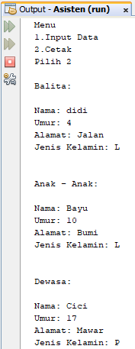

Keterangan Source Code :

------------------------------------------------------------------------------------------------------------------------------------------------------------------------------------------------------------------------------------------------------------------------------------------------------------------------------------------------------------------------------------------------------------------------------------------------------------------------------------------------------------------------------------------------------------------------------------------------------------------------------------------------------------------------------------------------------------------------------------------------------------------------------------------------------------------------------------------------------------------------------------------------------------------------------------------------------------------------------------------------------------------------------------------------------------------------------------------------------------------------------------------------------------------------------------------------------------------------------------------------------------------------------------------------------------------------------------------------------------------------------------------------------------------------------------------------------------------------------------------------------------------------------------------------------------------------------------------------------------------------------------------------

Print Out Source Code Program

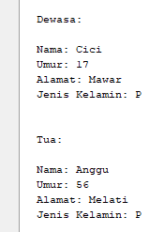

Keterangan Source Code :

------------------------------------------------------------------------------------------------------------------------------------------------------------------------------------------------------------------------------------------------------------------------------------------------------------------------------------------------------------------------------------------------------------------------------------------------------------------------------------------------------------------------------------------------------------------------------------------------------------------------------------------------------------------------------------------------------------------------------------------------------------------------------------------------------------------------------------------------------------------------------------------------------------------------------------------------------------------------------------------------------------------------------------------------------------------------------------------------------------------------------------------------------------------------------------------------------------------------------------------------------------------------------------------------------------------------------------------------------------------------------------------------------------------------------------------------------------------------------------------------------------------------------------------------------------------------------------------------------------------------------------------------